Unit 4 – Blockchain and Decentralized Applications
esp. Lab Manual (HyperLedger Besu)
Introduction to HyperLedger Besu, Solidity Programming with VS Code, Truffle
Objective:
In this lab, students will set up a local non-production blockchain environment using HyperLedger Besu with Truffle and Java, deploy a simple smart contract, and interact with it.
By the end of this lab, students will:
- Understand the basics of HyperLedger Besu.
- Write a simple smart contract and interact with it.

Extra cautions, dos and don’ts:
General environment
- Do keep folder names simple: no spaces in the lab root path.
- Do close all terminals after changing environment variables, then re-open VS Code.
- Don’t install Java using the “Compressed Archive” unless you’re comfortable with manual PATH setup.
- Don’t edit System Path randomly; only add new entries, never delete unknown ones.
Besu
- Do keep the Besu terminal open while compiling/migrating; if you close it, Truffle will fail with connection errors.
- Do check for “port already in use” errors and kill old nodes:
  - netstat -ano | findstr 8545
  - taskkill /PID <PID> /F
- Don’t run Ganache on port 8545 at the same time as Besu.
Truffle
- Do run npm init -y and npm install --save-dev @truffle/hdwallet-provider inside the Truffle project folder, not globally.
- Do keep truffle-config.js in sync with your actual Besu RPC URL and compiler version.
- Don’t rename contracts/ or migrations/ or move truffle-config.js elsewhere.
Keys and security
- Do repeat clearly: the given dev account key is public, only for this lab, never use it on any live network.
- Don’t reuse these keys on MetaMask, testnets, or mainnet.

Set up: 1. Installed Java (for Besu)
https://www.oracle.com/it/java/technologies/downloads/#jdk21-windows
Make sure the correct OS (Windows tab) is selected for your machine.

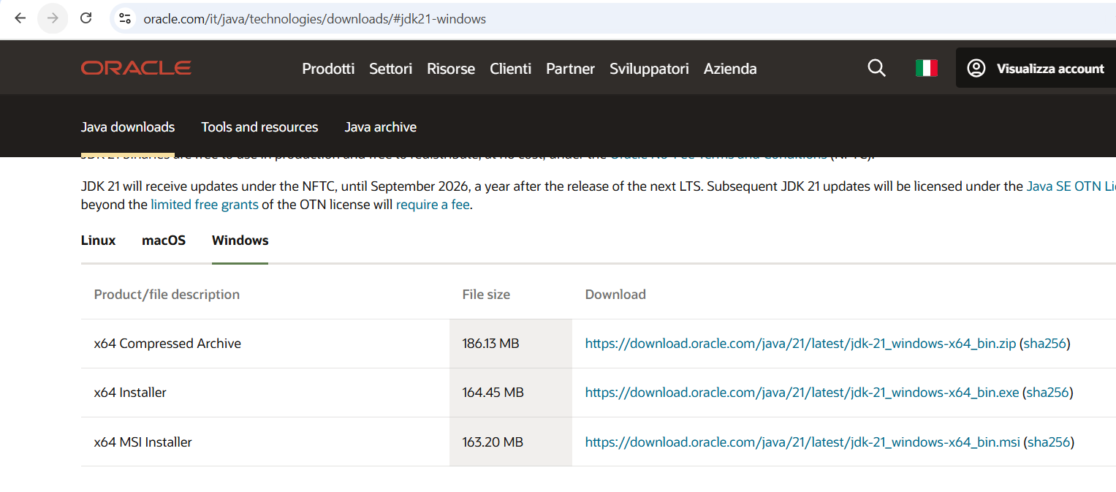

Do not use the “x64 Compressed Archive” for beginners; it requires manual PATH setup.
- Click the link in the Download column for x64 Installer
- Accept the license/terms if prompted and download.
- Run the downloaded .exe (or .msi) and in the installer:
  - Keep the default install location.
  - If you see options like “Set JAVA_HOME” or “Update PATH”, check them.
After installation, open the VS Code terminal and run:
java -version and javac -version
If you see a Java 21 version string, you’re ready to install Besu and continue the lab.

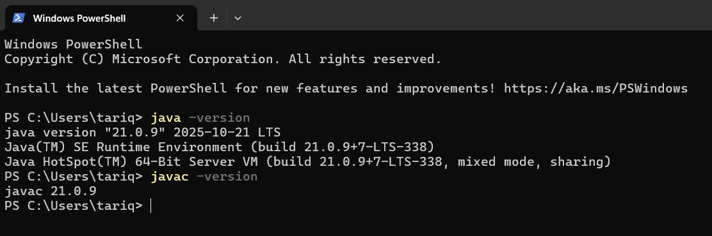

Also,
Check Java from the VS Code terminal
In VS Code: Terminal → New Terminal.
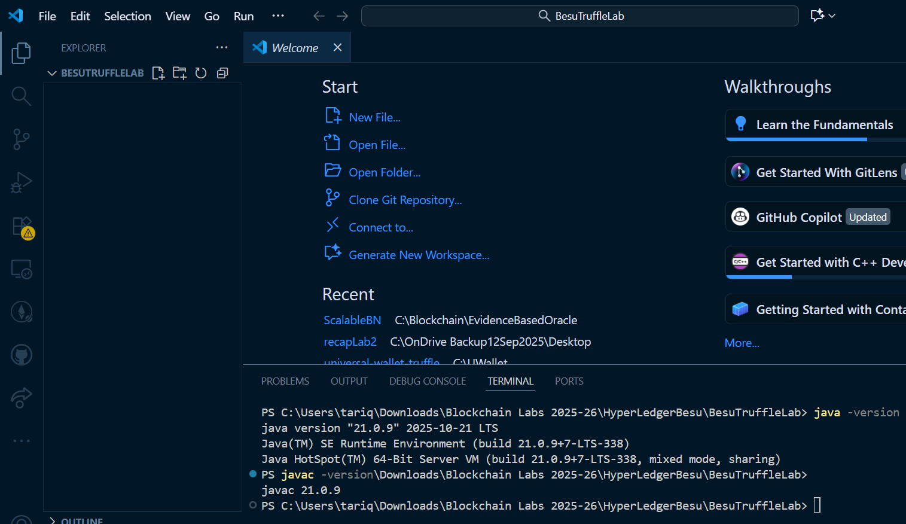

If you see: “'java -version’ is not recognized as an internal or external command...” and it fails, then you need JavaHome and a path pointing to it, because that means PATH is broken.
Copy the directory of the file where JDK is installed, like C:\Program Files\Eclipse\jdk-21.0.11.9

- Press Win → “environment variables” → “Edit the system environment variables” → “Environment Variables…”
- Under System variables:
- Click New…
  - Name: JAVA_HOME
  - Value: e.g. C:\Program Files\Eclipse Adoptium\jdk-21.0.11.9 (your actual JDK path)
- Select Path → Edit… → New → add:
  - %JAVA_HOME%\bin
- Click OK on everything, close VS Code, re-open, then run:

Set up: 2. We already installed, downloaded and checked Node and Truffle (but as a quick reminder)
node -v
npm -v
npm install -g truffle
truffle version

Set up: 3. Install Besu
3.1 Download and extract Besu
- Go to Hyperledger Besu download page and download the binary distribution ZIP for Windows. https://github.com/hyperledger/besu/releases/download/25.11.0/besu-25.11.0.zip
- Extract it somewhere. And locate besu.bat
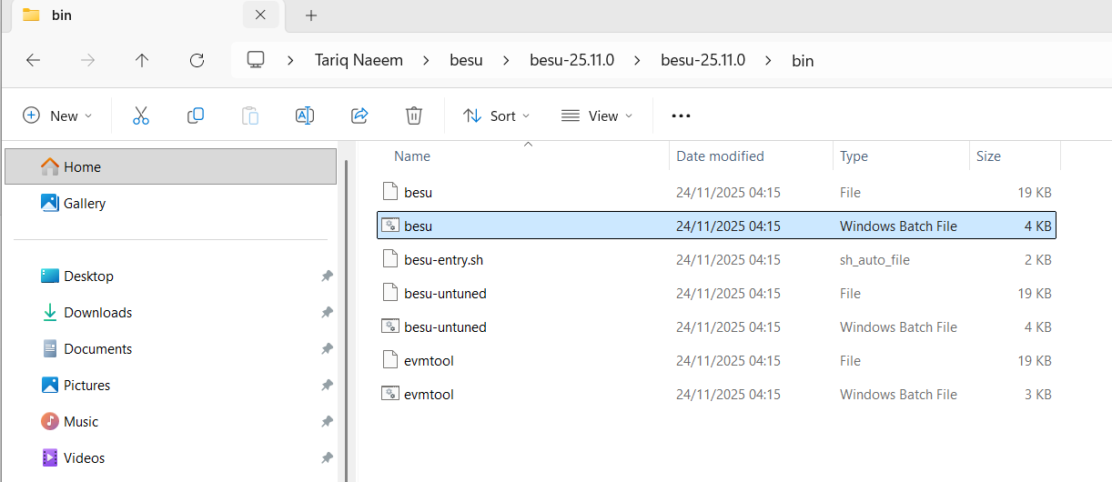

Mine is:
C:\Users\tariq\besu\besu-25.11.0\besu-25.11.0\bin

3.2 Add that folder to your user Path:
- Win → “environment variables” → Environment Variables…
- Under User variables (top box), select Path → Edit…
- Click New → paste your Besu bin path (e.g. C:\Besu\besu-25.11.0\bin).
- OK. Close VS Code and reopen.
- In VS Code terminal:

3.3 Verify Besu in VS Code terminal
- Close all VS Code windows.
- Re-open VS Code and open BesuTruffleLab
- Terminal → New Terminal, then run:
besu --version
- You should see the Besu version info. If not, PATH is still wrong; re-check the folder path
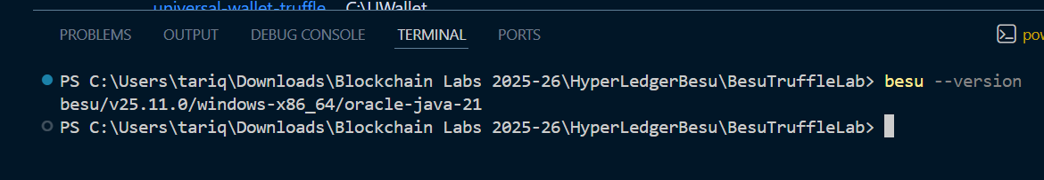

4. Start a local Besu dev node (for testing only)
Besu has a development mode (--network=dev) that uses a special genesis with low difficulty and test accounts.
One of the default test accounts:
- Address: 0xfe3b557e8fb62b89f4916b721be55ceb828dbd73
- Private key: 0x8f2a55949038a9610f50fb23b5883af3b4ecb3c3bb792cbcefbd1542c692be63
These keys are public and not safe (never) for real networks. They are for labs only.
4.1 Create a node folder and start Besu from VS Code
- In VS Code terminal (in C:\besu-truffle-lab):
mkdir besuNode
cd besuNode
- Start a dev Besu node (leave this terminal running):

besu `
--network=dev `
--miner-enabled `
--miner-coinbase=0xfe3b557e8fb62b89f4916b721be55ceb828dbd73 `
--rpc-http-enabled `
--rpc-http-port=8545 `
--host-allowlist="*" `
--rpc-http-cors-origins="all" `
--data-path=devchain

Or, use the full command in one line:

besu --network=dev --miner-enabled --miner-coinbase=0xfe3b557e8fb62b89f4916b721be55ceb828dbd73 --rpc-http-enabled --rpc-http-port=8545 --host-allowlist="*" --rpc-http-cors-origins="all" --data-path=devchain

Press enter. It will ask you to allow public and private networks; click Allow.

What do these commands mean?
--network=dev → use dev-mode genesis with test accounts
--miner-enabled/--miner-coinbase → node mines blocks so your transactions confirm quickly
--rpc-http-enabled / --rpc-http-port=8545 → enable HTTP JSON-RPC on http://127.0.0.1:8545 (Truffle will communicate here).
--host-allowlist="*" / --rpc-http-cors-origins="all" → easy local access (unsafe in production, fine for this lab only).

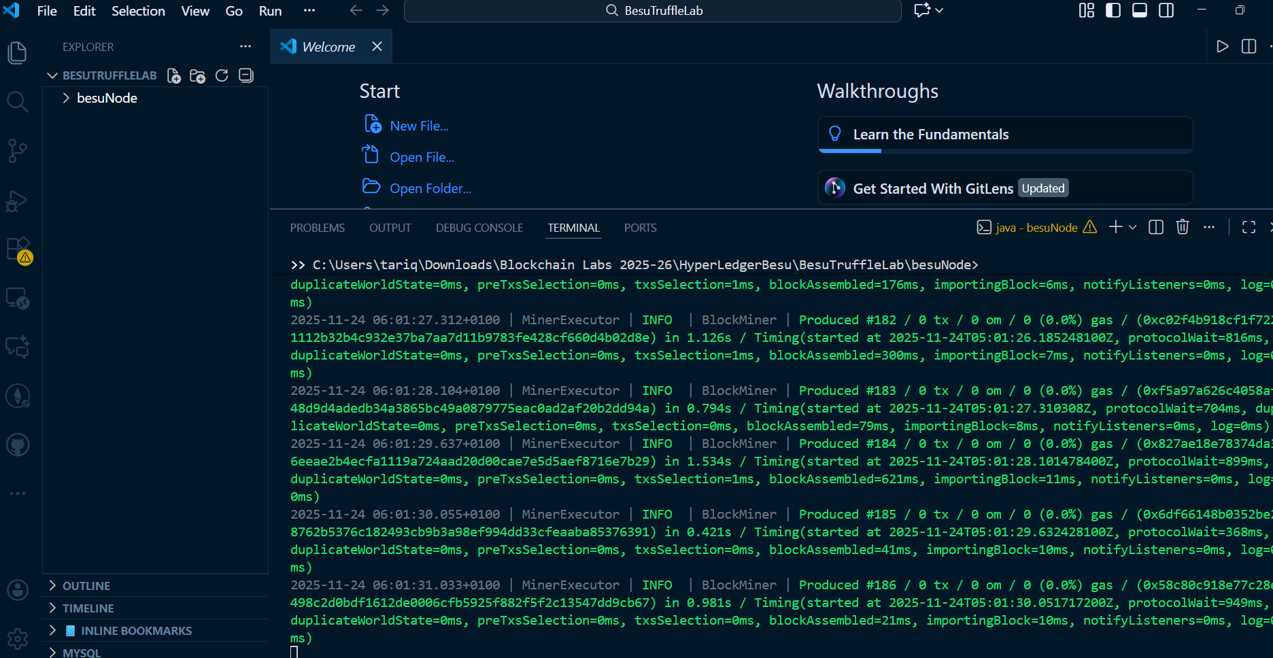

- Keep this terminal open. Please do not stop it while doing the Truffle part.

5. Create a Truffle project and connect it to Besu
You will now use another VS Code terminal for Truffle (careful).
5.1 New terminal for Truffle
- In VS Code, click the small + next to the terminal tab to open a second terminal.
- Make sure it is in the lab root:
cd C:\BesuTruffleLab
- Create a Truffle project folder:
mkdir truffleBesu
cd truffleBesu
- Initialize Truffle:
truffle init
This creates contracts/, migrations/, truffle-config.js, as you all are familiar with.

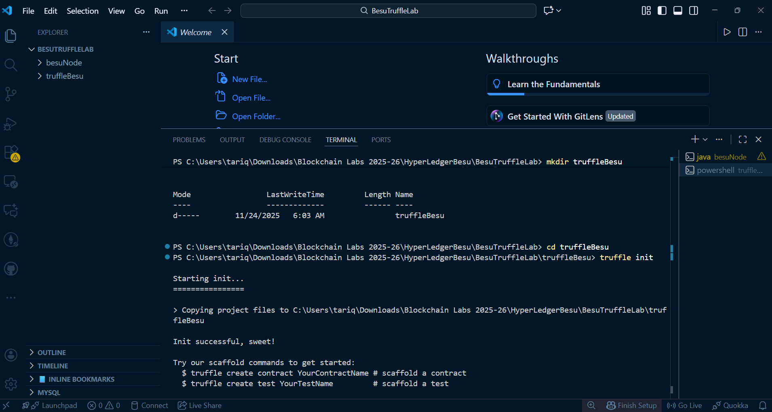

5.2 Install HDWalletProvider (to sign transactions with a private key)
Truffle needs a signer to send transactions to Besu (it uses eth_sendRawTransaction under the hood).
In the Truffle project terminal:
npm init -y
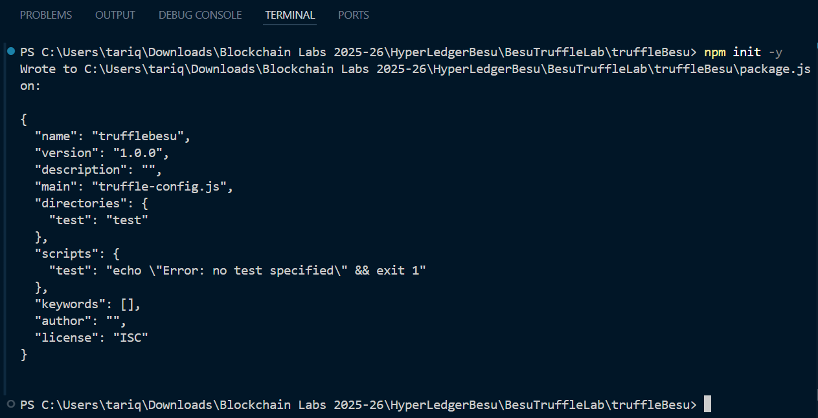

npm install --save-dev @truffle/hdwallet-provider
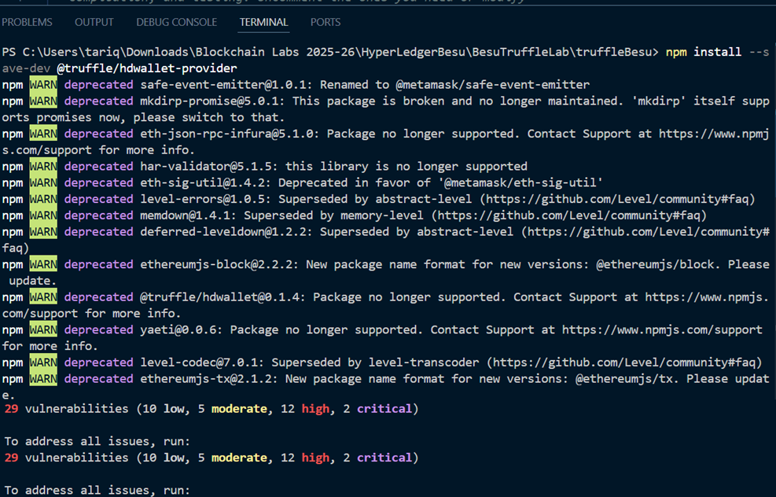

5.3 Configure truffle-config.js for Besu
Open truffle-config.js in VS Code and edit it to something like this:
const HDWalletProvider = require('@truffle/hdwallet-provider');

// Test private key from Besu dev mode (do NOT use on real networks)
const PRIVATE_KEY =
'0x8f2a55949038a9610f50fb23b5883af3b4ecb3c3bb792cbcefbd1542c692be63';

/**
* Truffle configuration for Hyperledger Besu dev network
*/
module.exports = {
networks: {
// Our Besu dev node running at http://127.0.0.1:8545
besuDev: {
provider: () =>
new HDWalletProvider({
privateKeys: [PRIVATE_KEY],
providerOrUrl: 'http://127.0.0.1:8545',
}),
network_id: '*', // accept any network id
},
},

// Use Solidity 0.8.19 (or close to what you want)
compilers: {
solc: {
version: '0.8.19',
},
},
};

This tells Truffle:
- Use the dev test account (with the public-private key above).
- Connect to Besu at http://127.0.0.1:8545.
- Use network_id: '*' so it does not care about the exact chain ID.

6. Write a simple Solidity contract
Target: something straightforward, but enough to see state changes.
Create contracts/SimpleStorage.sol:
// SPDX-License-Identifier: MIT
pragma solidity ^0.8.19;

contract SimpleStorage {
uint256 private storedValue;

event ValueChanged(uint256 newValue);

function set(uint256 _value) public {
storedValue = _value;
emit ValueChanged(_value);
}

function get() public view returns (uint256) {
return storedValue;
}
}

We made the variable private and provided a get() function to read it. If you mark it public, Solidity automatically generates a getter, and you can call instance.storedValue().

6.1 Create a migration script
Create migrations/2_deploy_simplestorage.js:
const SimpleStorage = artifacts.require('SimpleStorage');

module.exports = function (deployer) {
deployer.deploy(SimpleStorage);
};

7. Compile and deploy to Besu (from VS Code terminal)
Make sure:
- Terminal 1: Besu is running (no errors).
- Terminal 2: You are in C:\besu-truffle-lab\truffle-besu.
7.1 Compile
In Truffle terminal: truffle compile

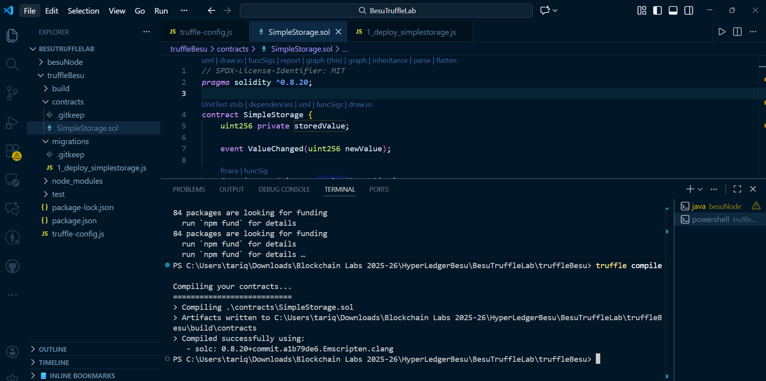

You should see compilation success.

7.2 Deploy (migrate) to Besu dev network
Still in the Truffle terminal:

truffle migrate --network besuDev

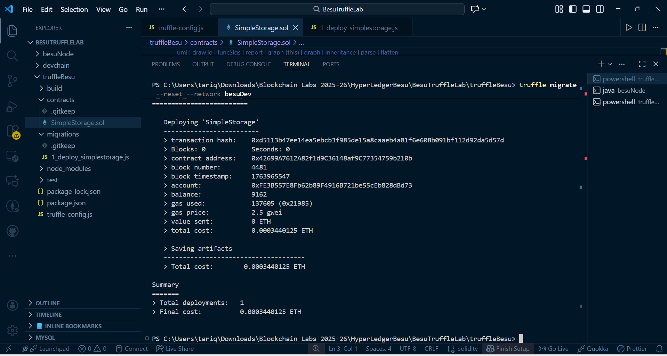

The output means everything is now wired correctly, and the deployment worked.

Note:
- It should print something like “Deploying 'SimpleStorage'...”
- Then a transaction hash and a contract address.
- No fatal errors.

If you see an error like:
"Invalid opcode: 0x5f"
it means the contract was compiled for a newer EVM (PUSH0 opcode) than our Besu dev network supports.
Fix: set Solidity compiler version to 0.8.19 with evmVersion: "london" in truffle-config.js, delete the build/ folder, and run:

truffle migrate --reset --network besuDev

If you see “connection refused”, Besu is not running, or the port is wrong.

If it is not migrating, please open and run the following commands:
netstat -ano | findstr 8545

tasklist /FI "PID eq 25736"

taskkill /PID 25736 /F

kill the process ID which was earlier used for ganache
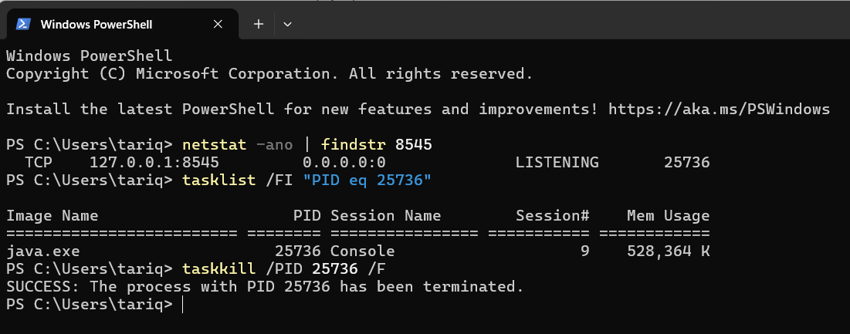
See the message – SUCCESS: The process with PID 25736 has been terminated.

8. Interact with the contract via Truffle console
8.1 Open Truffle console connected to Besu
In the Truffle terminal: truffle console --network besuDev
You’ll see a truffle(besuDev)> prompt.

8.2 Run commands in the console
At the truffle(besuDev)> prompt:
- Get the deployed contract instance:
const instance = await SimpleStorage.deployed();
- Read default value:
(await instance.get()).toString()
- Set a new value (this sends a transaction):
await instance.set(123);
- Read again:
(await instance.get()).toString()

Expected: 123.

Truffle signs transactions using the private key you configured, then sends them to Besu via JSON-RPC.

--------------------------------------------------------------------------------------------------------------------

Command sequence cheat sheet (for students)
This is what you should add near the end as a “Quick Reference”.

A. One-time setup (before lab, or at start)
- Check Java
java -version
javac -version

- If both show Java 21: OK.
- If “java is not recognized”: fix JAVA_HOME + %JAVA_HOME%\bin in Path.

- Check Node + NPM + Truffle
node -v
npm -v
truffle version

If truffle is missing:
npm install -g truffle

Check Besu PATH
besu --version

- If it prints a version: OK.
- If not recognized: add your Besu bin folder to user Path.

B. Every time you start the lab
Terminal 1 – start Besu node
cd C:\BesuTruffleLab
mkdir besuNode # first time only
cd besuNode

besu --network=dev --miner-enabled --miner-coinbase=0xfe3b557e8fb62b89f4916b721be55ceb828dbd73 --rpc-http-enabled --rpc-http-port=8545 --host-allowlist="*" --rpc-http-cors-origins="all" --data-path=devchain

- If you see “Port(s) [30303, 8545] already in use”:
netstat -ano | findstr 8545
taskkill /PID <PID> /F

- then run the besu command again.

Terminal 2 – Truffle project
First time:
cd C:\BesuTruffleLab
mkdir truffleBesu
cd truffleBesu

truffle init
npm init -y
npm install --save-dev @truffle/hdwallet-provider

Then create:
- contracts/SimpleStorage.sol
- migrations/2_deploy_simplestorage.js
- truffle-config.js (with 0.8.19 + london EVM config above)

C. Compile and deploy
From C:\BesuTruffleLab\truffleBesu:
- Compile: truffle compile
- Deploy: truffle migrate --network besuDev

If you see:
- “Could not connect to your Ethereum client”
→ Besu is not running / wrong port. Fix Terminal 1, then retry.
- “Invalid opcode: 0x5f”
→ Wrong compiler/EVM version. Set Solidity to 0.8.19 + evmVersion: "london", delete build/, then:
truffle migrate --reset --network besuDev

“HDWalletProvider is not defined” → Missing require or package. Check top of truffle-config.js:

const HDWalletProvider = require('@truffle/hdwallet-provider');

and rerun:
npm install --save-dev @truffle/hdwallet-provider

D. Interact with the contract
truffle console --network besuDev

In the console:
const instance = await SimpleStorage.deployed();

// Read initial value
(await instance.get()).toString();

// Change it
await instance.set(123);

// Read again
(await instance.get()).toString();

Expected: 123.
If you get TypeError: instance.get is not a function, it means you changed the contract and removed/renamed the get function; then you must either:
- Fix the contract to match the lab, or
- Call whatever getter you actually defined.

